1. Create Database
Query
CREATE DATABASE Library;
2. Use Database
Query
USE Library;
3. Create Table
Query
CREATE TABLE Book (
BookID INT PRIMARY KEY,
Title VARCHAR(255) NOT NULL,
Author VARCHAR(255) NOT NULL,
Publisher VARCHAR(255),
YearPublished INT
);
4. Insert Records
Query
INSERT INTO Book VALUES
(1, 'C Programming', 'Dennis Ritchie', 'PHI', 1988),
(2, 'Java Programming', 'James Gosling', 'Oracle Press', 2000),
(3, 'Database System', 'Korth', 'McGraw Hill', 2010),
(4, 'Operating System', 'Galvin', 'Wiley', 2015),
(5, 'Computer Networks', 'Tanenbaum', 'Pearson', 2003);
5. Display Table Records
Query
SELECT * FROM Book;
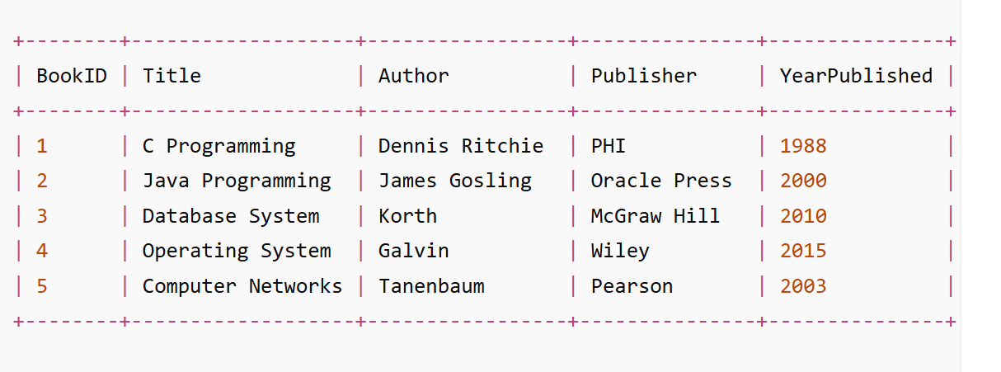

1. Create Table
Query
CREATE TABLE Member (
MemberID INT PRIMARY KEY,
Name VARCHAR(255) NOT NULL,
Address VARCHAR(255),
PhoneNumber VARCHAR(15),
Email VARCHAR(255)
);
2. Insert Records
Query
INSERT INTO Member (MemberID, Name, Address, PhoneNumber, Email) VALUES
(111, 'Prajwal', 'Chandanapuri', '9876543210', 'prajwal@gmail.com'),
(222, 'Prafull', 'Chalisgaon', '9123456789', 'prafull@gmail.com'),
(333, 'Shreyas', 'Sangamner', '9988776655', 'shreyas@gmail.com'),
(444, 'Sarthak', 'Nashik', '9090909090', 'sarthak@gmail.com'),
(555, 'Ayush', 'Loni', '9898989898', 'ayush@gmail.com');
3. Display Table Records
Query
SELECT * FROM Member;
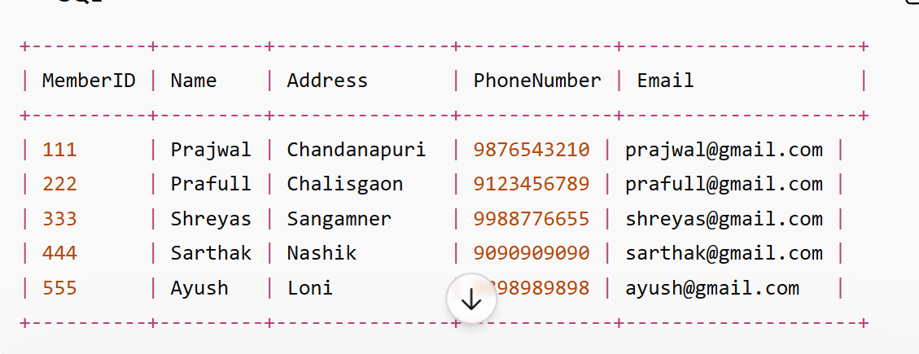
1. Create Table
Query
CREATE TABLE Loan (
LoanID INT PRIMARY KEY,
BookID INT,
MemberID INT,
LoanDate DATE,
ReturnDate DATE,
FOREIGN KEY (BookID) REFERENCES Book(BookID),
FOREIGN KEY (MemberID) REFERENCES Member(MemberID)
);

2. Insert Records
Query
INSERT INTO Loan (LoanID, BookID, MemberID, LoanDate, ReturnDate) VALUES
(1, 1, 111, '2026-02-01', '2026-02-10'),
(2, 2, 222, '2026-02-02', '2026-02-12'),
(3, 3, 333, '2026-02-03', '2026-02-13'),
(4, 4, 444, '2026-02-04', '2026-02-14'),
(5, 5, 555, '2026-02-05', '2026-02-15');

3. Display Table Records
Query
SELECT * FROM Loan;
